Count on Cantor

Problem

One of the famous proofs of modern mathematics is Georg Cantor's demonstration that the set of rational numbers is enumerable. The proof works by using an explicit enumeration of rational numbers as shown in the diagram below.

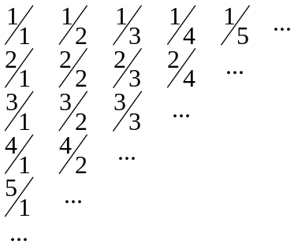

In the above diagram, the first term is 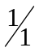, the second term is 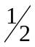, the third term is 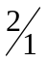, the fourth term is 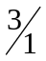, the fifth term is 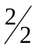, the sixth term is 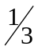, the seventh term is 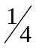, and so on.

Input/Output

You have been given a fully implemented immutable Fraction class. The Fraction class is used to represent Fractions and retrieve the numerator and denominator of the Fraction. The Fraction class has two methods, getNumerator() which returns the fractions numerator. The second method is getDenominator() which returns the fractions denominator. As shown I the example above, you shall NOT simplify the fractions.

You have also been given the incomplete RationalCounter class. You need to implement the static method, getFraction() which returns a Fraction. (You may create as many helper [private or public] methods and classes as needed).

The static method Fraction getFraction(int y) returns the y^{th} fraction in the sequence. For example, the following code segment produces the indicated results:
Fraction ans = RationalCounter.getFraction(3);
ans.getNumerator(); // returns 2
ans.getDenominator(); // returns 1

ans = RationalCounter.getFraction(14);
ans.getNumerator(); // returns 2
ans.getDenominator(); // returns 4

ans = RationalCounter.getFraction(7);
ans.getNumerator(); // returns 1
ans.getDenominator(); // returns 4

